REPORT ON HEATING

INTRODUCTION:

**Heating systems can use many different ways to move energy. Most commonly, air is heated or cooled, then circulated through the building. Energy can also be moved as steam, hot water, electricity, gas, or other means. Controls are the systems that control whether heat or cooling or ventilation is provided.**

**A heating system is a mechanism for maintaining temperatures at an acceptable level; by using thermal energy within a home, office, or other dwelling. Often part of an HVAC (heating, ventilation, air conditioning) system.**

**This system comes with primary heating applications such as a furnace, boiler, and heat pumps. Each heat source is rather unique and uses different methods of distributing heat into the targeted environment. Furnaces use ducts to blow heated air through in order to disperse the generated energy.**

TYPES OF HEATING SYSTEM:

1. FORCED AIR SYSTEM

* **Common type of home heating system**
* **Distribution air from furnace through installed ductwork and vents.**
* **Air can be heated with various fuel source- natural gas, propane, oil or electricity**
* **Ductwork takes space in the walls.**
* **May distribute allergens through moving air**

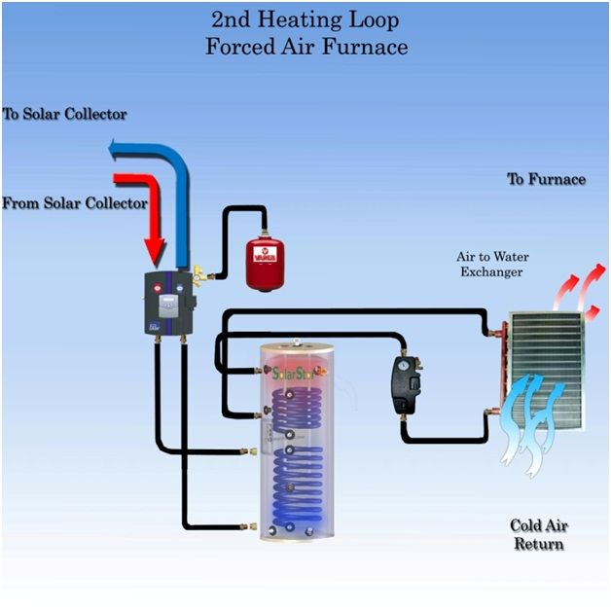

1. RADIANT HEAT SYSTEM

* **Can provide natural and comfortable heat**
* **Heat is providing via hot water tubes embedded in the floor or within the celling**
* **Hot water is heated by a boiler, fueled by oil, natural gas, propane or electricity**
* **May take time to heat a room**
* **Expensive installation and maintenance**

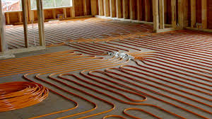

1. HYDRONIC SYSTEM

* **Uses hot water heated by a boiler**
* **Heat circulates in each room through tubes located in baseboard heating units attached to the wall**
* **Controls temperature in each room separately**
* **Energy efficient**
* **Temperature rises slowly**

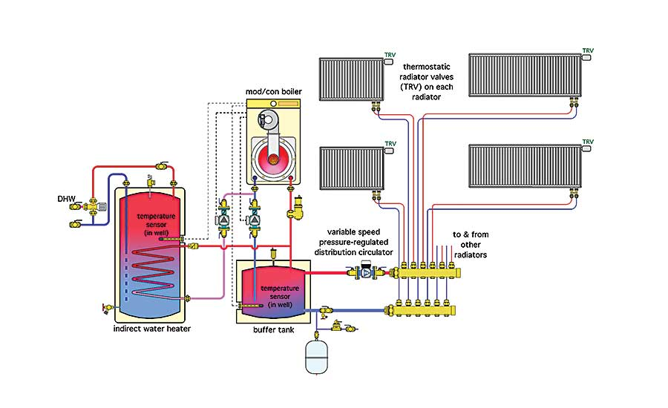

1. STEAM RADIANT SYSTEM

* **Heat room through radiators**
* **Two varities-one-pipe and two-pipe system**
* **Heat water through electricity, oil ,or natural gas**
* **Inconvenient for furniture placement and window covering**

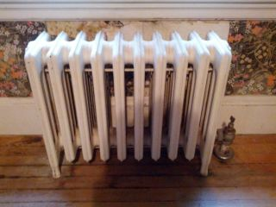

1. GEOTHERMAL SYSTEM

* **Newest technology for heating and cooling**
* **Mostly used in home and eco-conscious office spaces**
* **Internal temperature is regulated through natural heat from the ground**
* **System is not cheap to install**

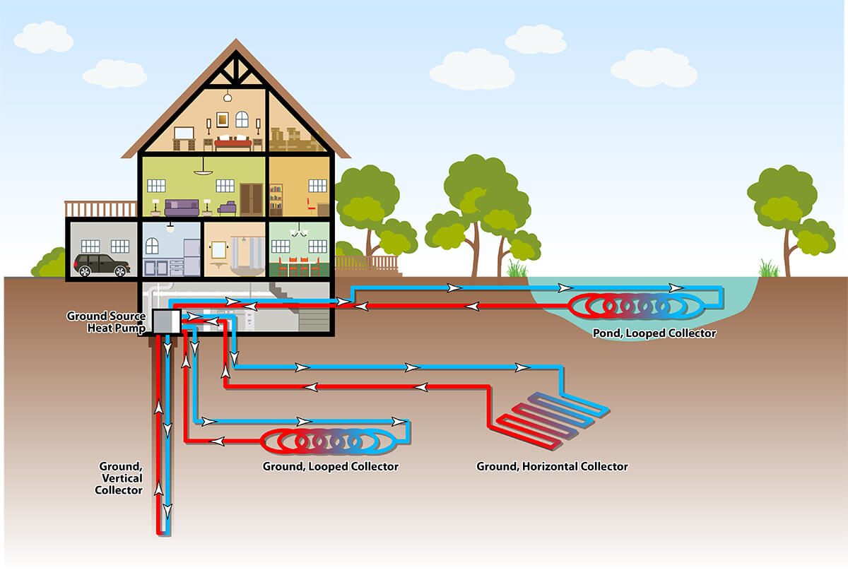

MODE OF HEATING:

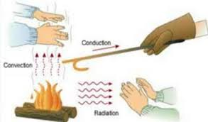

1. CONDUCTION:

* **Conduction transfers heat via direct molecular collision.**
* **An area of greater kinetic energy will transfer thermal energy to an area with lower kinetic energy.**
* **Higher-speed particles will collide with slower speed particles.**
* **The slower-speed particles will increase in kinetic energy as a result.**

1. CONVECTION:

* **Convective heat transfer, often referred to simply as convection, is the transfer of heat from one place to another by the movement of fluids.**
* **Convection is usually the dominant form of heat transfer in liquids and gases.**
* **Although often discussed as a distinct method of heat transfer, convective heat transfer involves the combined processes of unknown conduction (heat diffusion) and advection (heat transfer by bulk fluid flow).**

1. RADIATION:

* **Thermal radiation, process by which energy, in the form of electromagnetic radiation is emitted by a heated surface in all directions and travels directly to its point of absorption at the speed of light; thermal radiation does not require an intervening medium to carry it.**
* **Thermal radiation ranges in wavelength from the longest infrared rays through the visible-light spectrum to the shortest ultraviolet rays.**

VARIOUS TYPES OF PASSIVE STRATEGIES FOR HEATING:

Passive heating

**Passive heating refers to technologies or design features used to heat buildings without power consumption.**

**The term “passive” implies energy consuming mechanical components like pumps and fans are not used.**

**Building design attempts to integrate the principles of physics into the building exterior envelope.**

DIRECT SOLAR GAIN:

**Direct solar gain is the heat from the sun being collected and contained in an occupied space.**

**Direct solar gain is very important for any site that needs heating, because it is the simplest and least costly way of passively heating a building with the sun.**

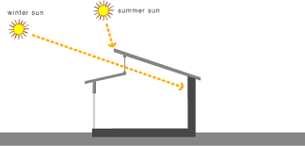

MASSING AND ORIENTATION OF HEATING:

**Massing and orientation are important design factors to consider passive heating.**

**Consider these factors early in the design so that the surface areas exposed to the sun at different times of the day, buildings orientation and building dimension can be optimized for passive comforts.**

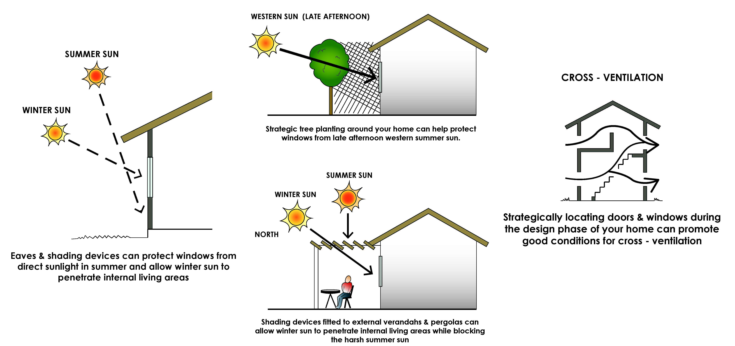

APERATURES FOR HEATING:

**Windows and other apertures can bring heat from sun but can also loose heat by radiant cooling and by conducting heat better that most wall or roofs construction.**

**Apertures and shading must be placed properly to take advantages of sun’s heat in cold area and climate.**

SHADING FOR SOLAR GAIN:

**Shades can keep the heat and glares of direct sun from coming through the window.**

**They can also keep direct sunlight off the walls or the roof to reduce cooling loads.**

